1 run......

Downloading: 100%

411/411 [00:00<00:00, 6.10kB/s]

Downloading: 100%

263M/263M [00:12<00:00, 23.1MB/s]

training 1 epoch...

70.92993068695068 seconds used......

1 training finished! average train loss: 1.028767122754029

evaluating...

Confusion matrix, without normalization

[[ 44 62 18]

[ 38 104 22]

[250 172 443]]

Normalized confusion matrix

[[0.35483871 0.5 0.14516129]

[0.23170732 0.63414634 0.13414634]

[0.28901734 0.19884393 0.51213873]]

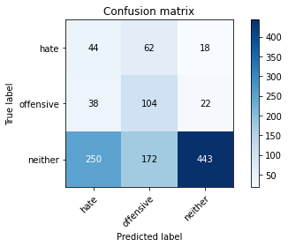

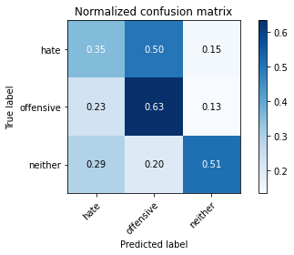

precision recall f1-score support

hate 0.13 0.35 0.19 124

offensive 0.31 0.63 0.41 164

neither 0.92 0.51 0.66 865

accuracy 0.51 1153

macro avg 0.45 0.50 0.42 1153

weighted avg 0.75 0.51 0.57 1153

average eval_loss: 0.9966033594361667, accuracy: 0.5125758889852559

training 2 epoch...

70.06165528297424 seconds used......

2 training finished! average train loss: 0.8972037544562703

evaluating...

Confusion matrix, without normalization

[[ 75 46 3]

[ 84 72 8]

[560 98 207]]

Normalized confusion matrix

[[0.60483871 0.37096774 0.02419355]

[0.51219512 0.43902439 0.04878049]

[0.64739884 0.1132948 0.23930636]]

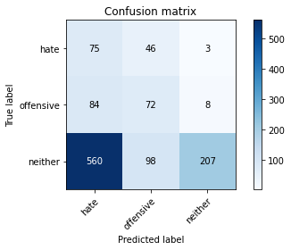

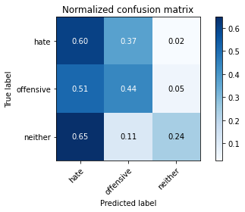

precision recall f1-score support

hate 0.10 0.60 0.18 124

offensive 0.33 0.44 0.38 164

neither 0.95 0.24 0.38 865

accuracy 0.31 1153

macro avg 0.46 0.43 0.31 1153

weighted avg 0.77 0.31 0.36 1153

average eval_loss: 1.108964275697182, accuracy: 0.3070251517779705

training 3 epoch...

69.97491502761841 seconds used......

3 training finished! average train loss: 0.7514404230529353

evaluating...

Confusion matrix, without normalization

[[ 69 46 9]

[ 71 82 11]

[412 103 350]]

Normalized confusion matrix

[[0.55645161 0.37096774 0.07258065]

[0.43292683 0.5 0.06707317]

[0.47630058 0.11907514 0.40462428]]

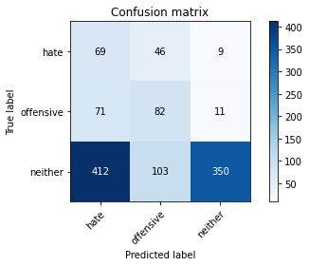

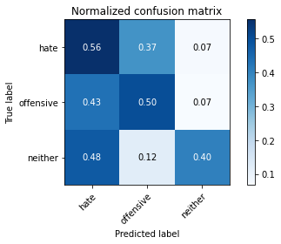

precision recall f1-score support

hate 0.12 0.56 0.20 124

offensive 0.35 0.50 0.42 164

neither 0.95 0.40 0.57 865

accuracy 0.43 1153

macro avg 0.48 0.49 0.40 1153

weighted avg 0.77 0.43 0.51 1153

average eval_loss: 1.118345136272496, accuracy: 0.43451864700780574

training 4 epoch...

70.04425573348999 seconds used......

4 training finished! average train loss: 0.5158421049515406

evaluating...

Confusion matrix, without normalization

[[ 44 58 22]

[ 36 106 22]

[196 165 504]]

Normalized confusion matrix

[[0.35483871 0.46774194 0.17741935]

[0.2195122 0.64634146 0.13414634]

[0.2265896 0.19075145 0.58265896]]

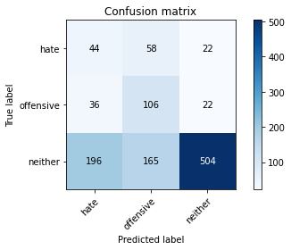

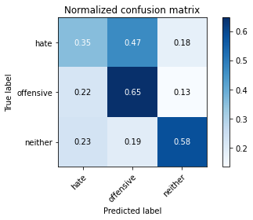

precision recall f1-score support

hate 0.16 0.35 0.22 124

offensive 0.32 0.65 0.43 164

neither 0.92 0.58 0.71 865

accuracy 0.57 1153

macro avg 0.47 0.53 0.45 1153

weighted avg 0.75 0.57 0.62 1153

average eval_loss: 1.0853969578085274, accuracy: 0.5672159583694709

training 5 epoch...

70.131178855896 seconds used......

5 training finished! average train loss: 0.25420601450882496

evaluating...

Confusion matrix, without normalization

[[ 62 42 20]

[ 68 74 22]

[297 105 463]]

Normalized confusion matrix

[[0.5 0.33870968 0.16129032]

[0.41463415 0.45121951 0.13414634]

[0.3433526 0.12138728 0.53526012]]

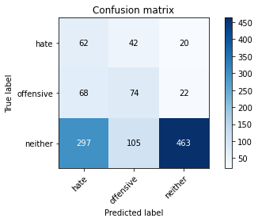

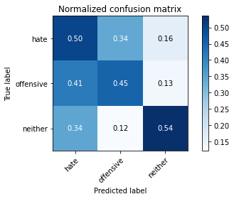

precision recall f1-score support

hate 0.15 0.50 0.23 124

offensive 0.33 0.45 0.38 164

neither 0.92 0.54 0.68 865

accuracy 0.52 1153

macro avg 0.47 0.50 0.43 1153

weighted avg 0.75 0.52 0.59 1153

average eval_loss: 1.451785125609102, accuracy: 0.5195143104943626

2 run......

training 1 epoch...